  - Banco Federal de Finanças
  - Marketing Campaign Analysis

Presented by:

Lauren Condie
- Background
A campaign was run attempting to entice more individuals to subscribe to a bank term deposit with Banco Federal de Finanças, but after management was unhappy with the results, our team was tasked with reviewing the campaign data in an attempt to find trends and insights leading to successful campaign outcomes. We will be looking at characteristics and demographics of customers as well as patterns in the economy to help narrow down to those individuals who are most likely to subscribe to a term deposit.
- Future Marketing Prediction Success
After creating a statistical model, we found that targeting customers predicted to subscribe increased success rates from 11% to over 35%. This indicates that the model can meaningfully improve future campaign performance by prioritizing high-probability customers.
- Key Findings
Who is most likely to say “yes” to this campaign?
What external factors could improve success rates?

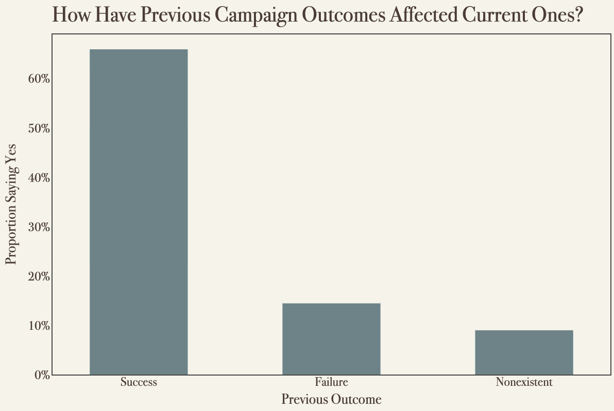
Customers with previous positive responses are more likely to subscribe again.
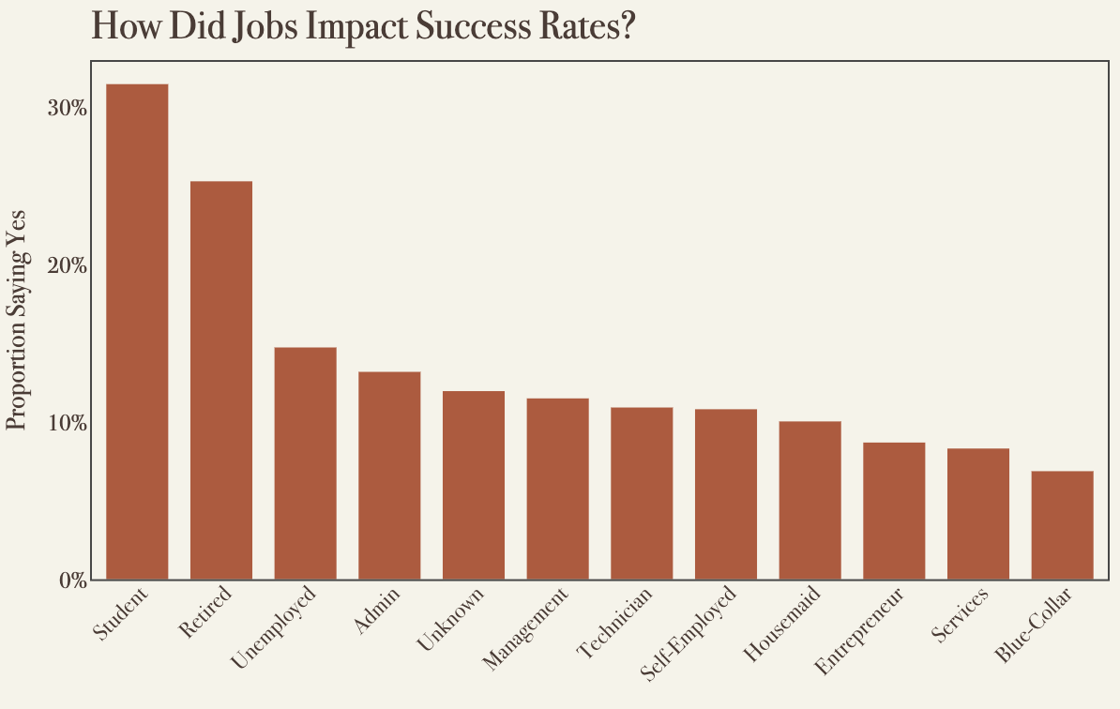
Students and those who are retired have a higher likelihood of subscribing.
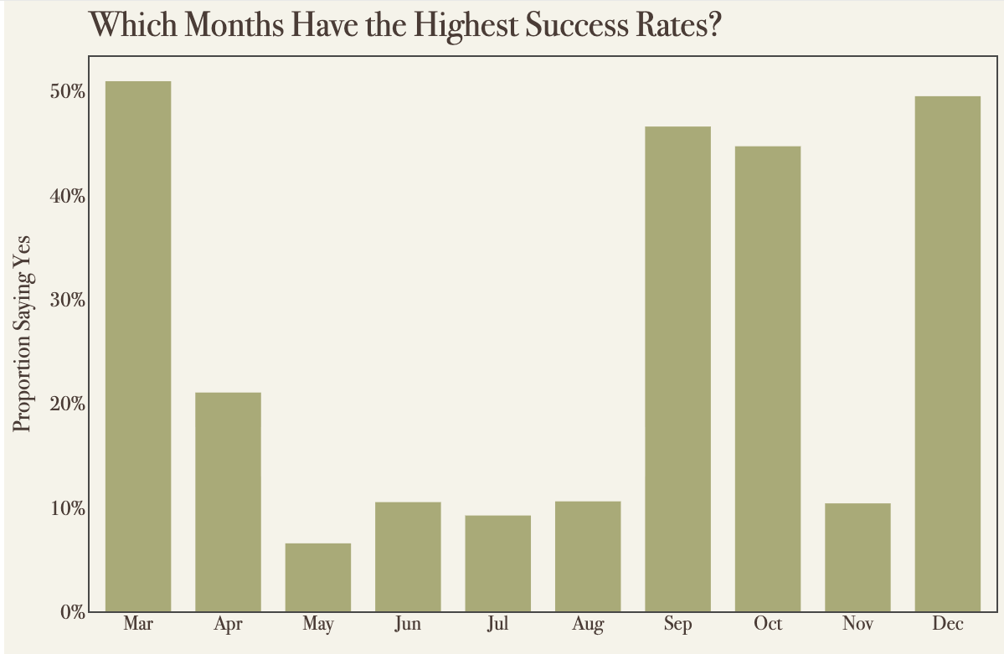
Our data shows that March, September, October, and December are the best months to run the campaign.
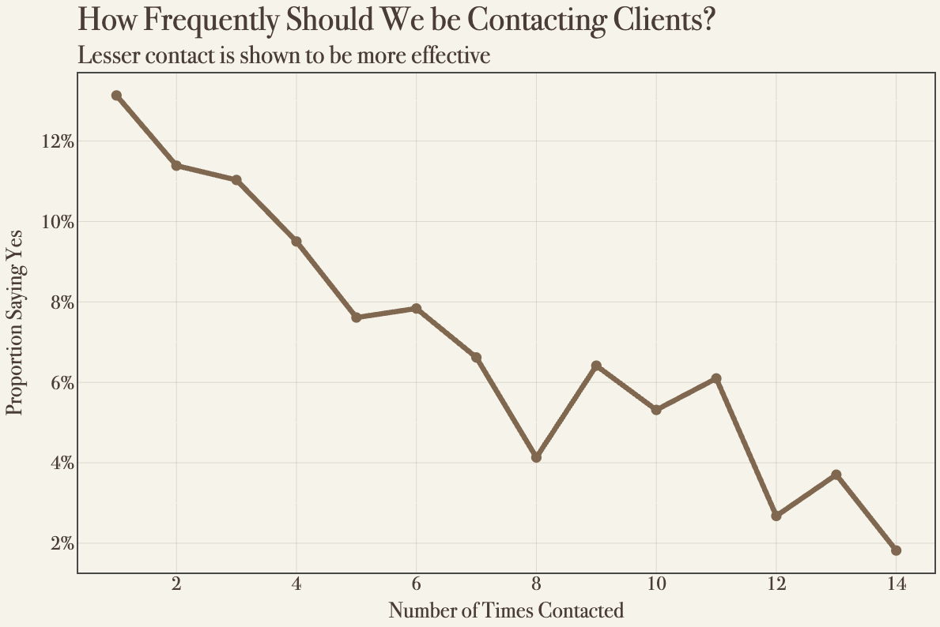
The more a customer is contacted, the less likely they are to say yes.
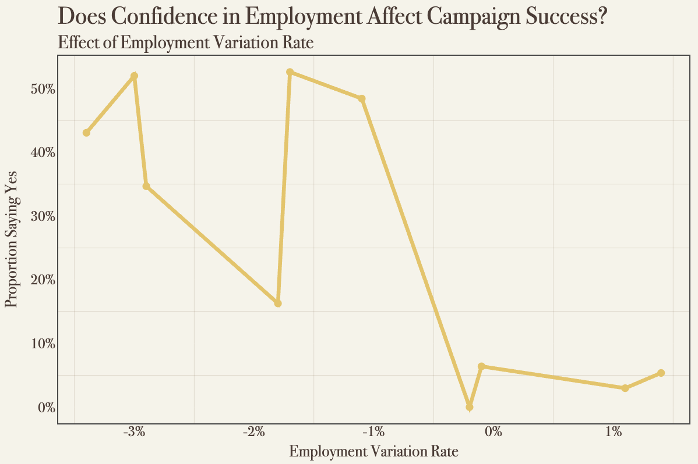
Higher consumer confidence, as reflected by the employment variation rate, is generally associated with increased campaign success, though the effect varies.
- Recommendations
While more variables were used to predict subscription success rates, the factors above played the largest roles in making accurate predictions. Based on this, the recommendations we have are:
- Focus on March, September, October, December campaigns
- Target students and retirees
- Avoid contacting the same customer repeatedly
- Monitor consumer confidence, especially employment rates, for timing campaigns
- Conclusion
By targeting campaigns toward these groups and considering these factors, Banco Federal de Finanças can allow the bank to prioritize and target their campaign to those who are more likely to subscribe, which can lead to increases in subscription rates as well as strengthening customer relationships.
- Methods Used
We decided to use logistic regression to predict what factors impacted whether someone said subscribed. It's ideal for binary 1/0 (yes or no) predictions and for our model, when compared with other machine learning methods like Decision Tree and Random Forest, it gave the best recall and accuracy.
Features in the model included consumer confidence, and employment rate, as well as campaign variables like previously contacted, month of contact, and customer demographics (age, marital status, job, education, housing, and loan).
Our logistic regression model was fitted to the data with L1 regularization to help focus on the most predictive features. The model also used class weighting to account for their being an imbalance in the dataset, as there were significantly more “no” than “yes” responses.
Our model’s performance was measured by accuracy and recall with accuracy reaching 0.827 and a recall score of 0.66. This means that our model made correct predictions 82.7% of the time and correctly identified 66% of those customers who subscribed. This balanced identifying “yes” responses while maintaining a reasonable accuracy.

- Python Notebooks
Below are Github Gist links to the notebooks used during this case study:
https://gist.github.com/laurencondie/9c3a0e76668d6d7349dbe843ac37c3ec

